IPV4 RANGE

0.0.0.0 – 255.255.255.255

public IP – ex. 54.86.23.90 → internet
private IP – ex. 192.168.1.10 – private IP

private IP ranges:

Class A 10.0.0.0 - 10.255.255.255
Class B 172.16.0.0 - 172.31.255.255
Class C 192.168.0.0 - 192.168.255.255

Protocols:
Protocols are nothing, just a formal specifications that defines the procedures that must be followed when transmitting or receiving data.

TCP and UDP protocols

TCP:
Reliable protocol. Gives surety that your data will be transmitted. Because it performs 3 way handshake before transferring the data and share acknowledgment.

And based on the acknowledgment there will be error detection, if something fails, if packet gets dropped/corrupted in the middle. The error will be found out and data will be re-transmitted.
Examples – FTP, HTTP, HTTPS

UDP:
Unreliable protocol.
It sends the data and forget about it whether it received or not.
It is faster than the TCP which is why it is being used.
No proper sequences.
ex. DNS,DHCP,TFTP,ARP.

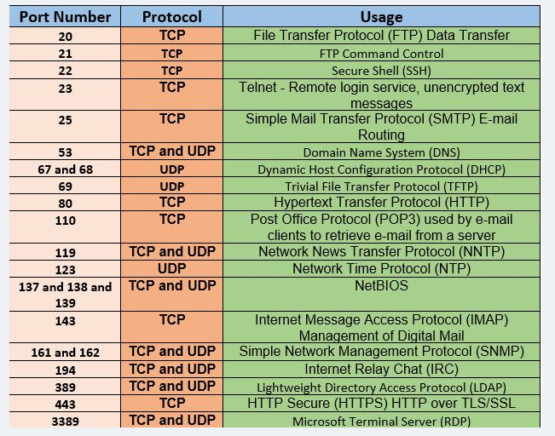

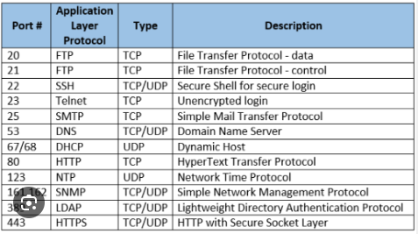

Network commands:
- add IP and name in hostfile to
- tracert/mtr www.google.com → this command will give all hops, IP address, latency and name of the hops to reach google server.
- Netstat -antp or ss -tunlp -- > these command will show all of the tcp open ports in the current machine.
- Ps -ef→ this commands to see all the running process ids.
- Dig/nslookup www.google.com → this command is used to retrieve the information about the DNS name servers. It is used for verifying and troubleshooting DNS problems and perform DNS lookups.
- Route -n → This command is going to show gateways.
- Arp → this command is to view or add content to the kernal arp table. Kernal maintains a table or ip or name and mapping mac address.
- Telnet (192.168.40.12 3306)IP address of machine port no→ command to connect with the another host using telnet protocol. You can use it to connect to a remote server by specifying the host and the port.

Containers:
Docker:
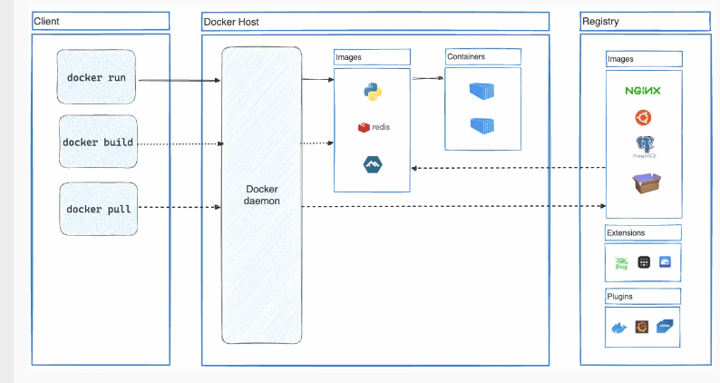
docker commands:
- systemctl status docker
- systemctl start docker
- docker run
- docker images → to check the docker images.
- Docker ps → to check running docker images
- docker ps -a → to check all images.
- docker run --name web01 -p 9080:80 nginx → this is running docker with nginx image.
- Docker inspect → to check the network details of docker image.

Micro-services:

services which are deployed separately/running isolated on server and interacting with each other using API gateway.
Best way is to containerize them using docker.

